README
1、请使用QT 5进行开发，下图是部分编译器信息。Please use QT 5 for development. The following figure shows some compiler information.

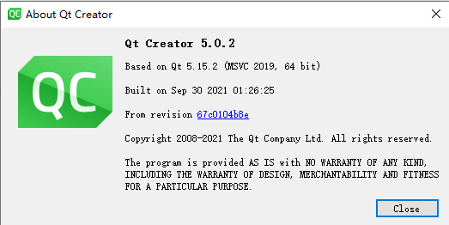
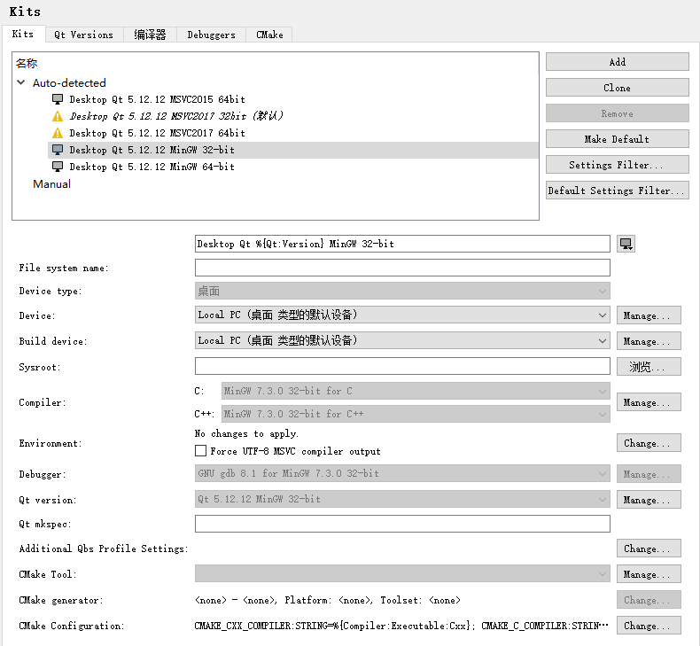

2、使用MinGW 32-bit可直接编译，msvc可能需要解决小部分的报错。 Use MinGW 32-bit to compile directly, and msvc may need to solve some errors

